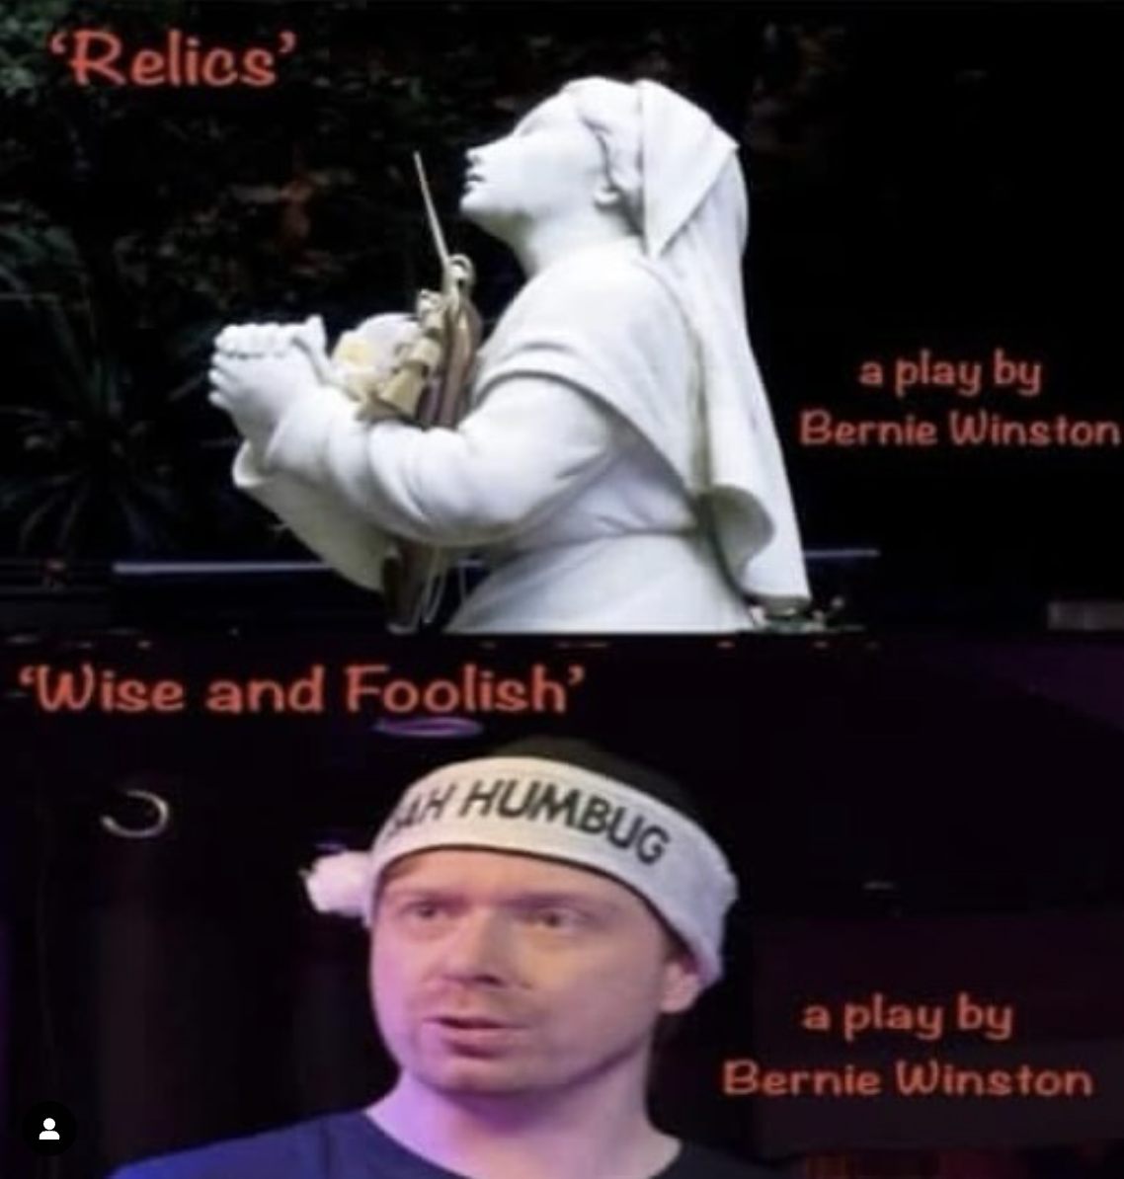

**AMATEUR THEATRE REVIEW: Wise and Foolish & Relics – 2 Plays By Bernie Winston**

Friday nights used to be spent getting ready to paint the town red, but on Friday 14th March, whilst I was planning on going into town, I was actually going to spend my night at what was Liverpool based *Studio Beyonds* inaugural show, and it was essentially two plays for the price of one. Now there is a buy-one-get-one-free I will gladly jump on any day of the week! On the double bill that night was ‘WISE and FOOLISH’ and ‘RELICS’, both plays written and directed by the very brilliant Bernie Winston. And whilst the theme of family dynamics and drama linked the two plays, the way these stories were told couldn’t have been more different.

Upon entering the theatre, I was met by a space that had black curtain hanging down snugly around the stage (and the walls around the whole room), where two chairs, one adorned with a pink shirt, the other a black jacket, were set. When the lights went to black, telling us audience members to quieten down as the show was about to start, on walked ‘Brian’ dressed in simple black. In ‘**WISE and FOOLISH**’, Luke Morgan brought us into the world of this young and proud Liverpudlian, and takes us through snapshot moments of a few weeks of his life. This was a one-man-show, which must be one of the most daunting performances to be in! You are front and centre, nobody there to give you a gentle nudge if you lose your way and you have to carry the whole thing. And to give credit where credit is due, Luke Morgan absolutely smashed it! Brian finds himself in London having been invited by his brother Joe after a not so enjoyable Christmas at home where the change in Joe is evident. The big brother Brian knew, and hero worshipped is different now, influenced by his partner Katherine (with ‘K’!), and the London friends he has made. The differences are further amplified on this trip when a night out with the

Londoners leaves Brian feeling awkward and out of place.

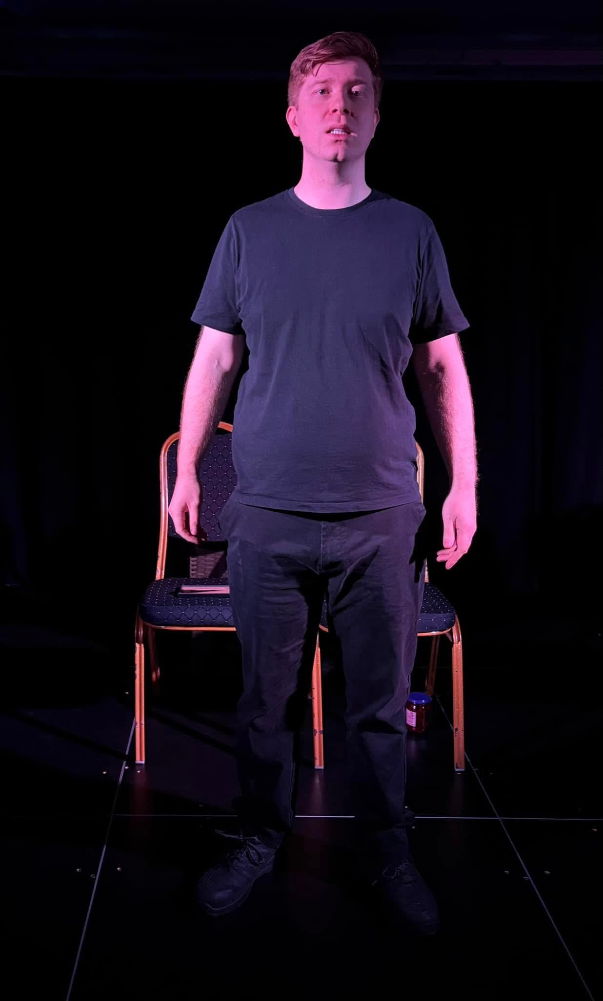

Throughout Luke’s performance, it just felt like a friend talking about what’s been going. He even acknowledged the audience’s presence as the second person in the conversation, silently listening to the story, that is when we weren’t laughing at the more comical moments – I’m looking at you, ‘scene in the Jamaican record shop’! Now, have I heard a better Jamaican accent? Sure, but did Luke give it a good go? Yes! But also, I don’t think our director was actually seeking perfection, which helped endear us to ‘Brian’ (and Luke!) even more. The ‘specially’ cooked scouse meal that Brian made for Joe and Katherine resulted in a hilarious scene that was also a true showing of how far apart him and Joe had drifted.

With two onstage ‘outfit’ changes (putting on and taking off the pink shirt and black jacket), sound effects/music clippings (I enjoyed the Reggae music moments), and story point props, particularly the poignant photo frame, all supported the atmosphere already created by Luke, and Bernie’s dialogue. We also got to see some emotional moments, after a devastating phone call and the quickest drive to Liverpool. The lights turned red to make us feel the dread felt by Brian, and signified how different life would be from now. Luke pitched that feeling of being on the edge of crying but keeping strong just right but your heart did break for him. Luckily, a chance meeting with a woman at the bar in London on that awkward night out (with an improvised business card exchange) gives Brian a light at the end of the tunnel after everything falls apart, leaving the audience with a sense of hope for him.

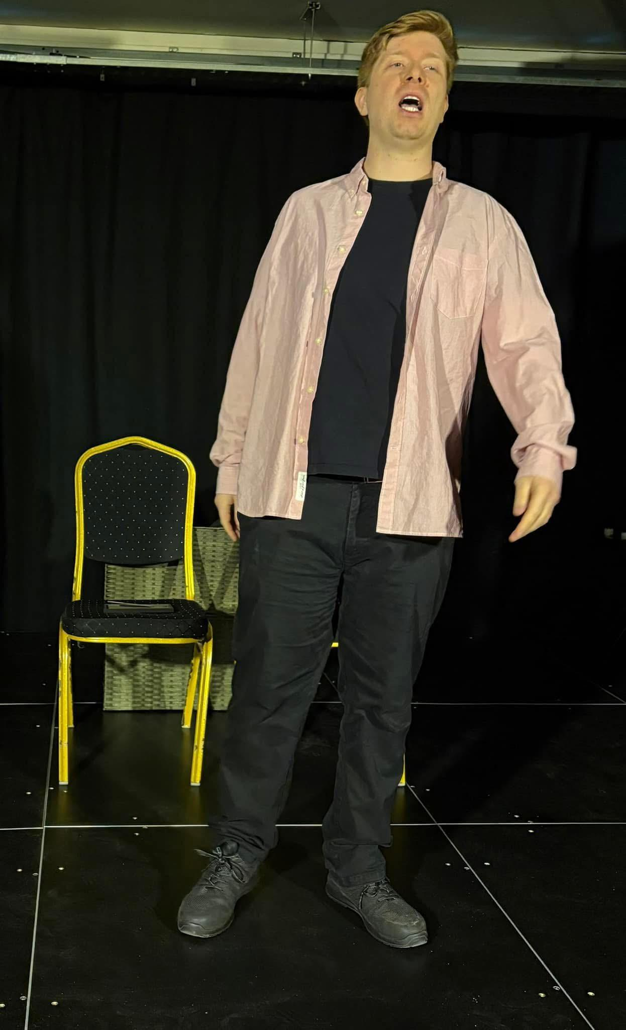

From a one-man-show to a cast of four (or five if we count Charlie the budgie’s tweet tweet sound effects!), **‘RELICS’** was the second of the night’s entertainment. Kate Harcus, playing ‘Grace’, and Nina Price, playing her daughter Berni, walked to stand in front of the stage and music started playing. Then the music stopped and then there were warm smiles between Grace and Nina, so I thought they must be about to sing without a backing track, but then the music started again. Only then did I realise this was one of those opening night mishaps where the wrong button was accidentally pressed but I was convinced by the smiles between Kate and Nina that it was all part of the show! And to be fair, it actually fit quite well for the show we ended up watching! Their voices melded so perfectly together as they sang a beautiful rendition of “Song of Bernadette, ” which has already been added to my favourite’s playlist!

The play is about three generations of a Catholic family of women, each dealing with their own issues and brought together under one roof because life can be so unpredictable. After the opening number, we settle into the story that sees ‘Gran’ played by Liz Hardy, basically forced by her daughter ‘Grace’ into moving in with her after a health scare. Berni also finds herself forced into moving back home, with boyfriend Steven, played by James Lawrence, as they are dealt an all too familiar real world setback. So Grace has to make her peace with having to share her space as when family needs you, you have to step up.

The setting again was simple - a table with a green and white gingham cover, chairs, various props on the table and around the stage. The black curtain surrounding the stage really helped create a cosy and intimate atmosphere that felt like I was looking through the window of someone’s house as they go about their day! Also, are we sure these actresses aren’t actually related because their chemistry was so believable! There is the Gran with all the opinions and all too happy to give them, her daughter who is managing her mother and dealing with the day to day, and the granddaughter often being the voice of reason, they were literally like a real family!.

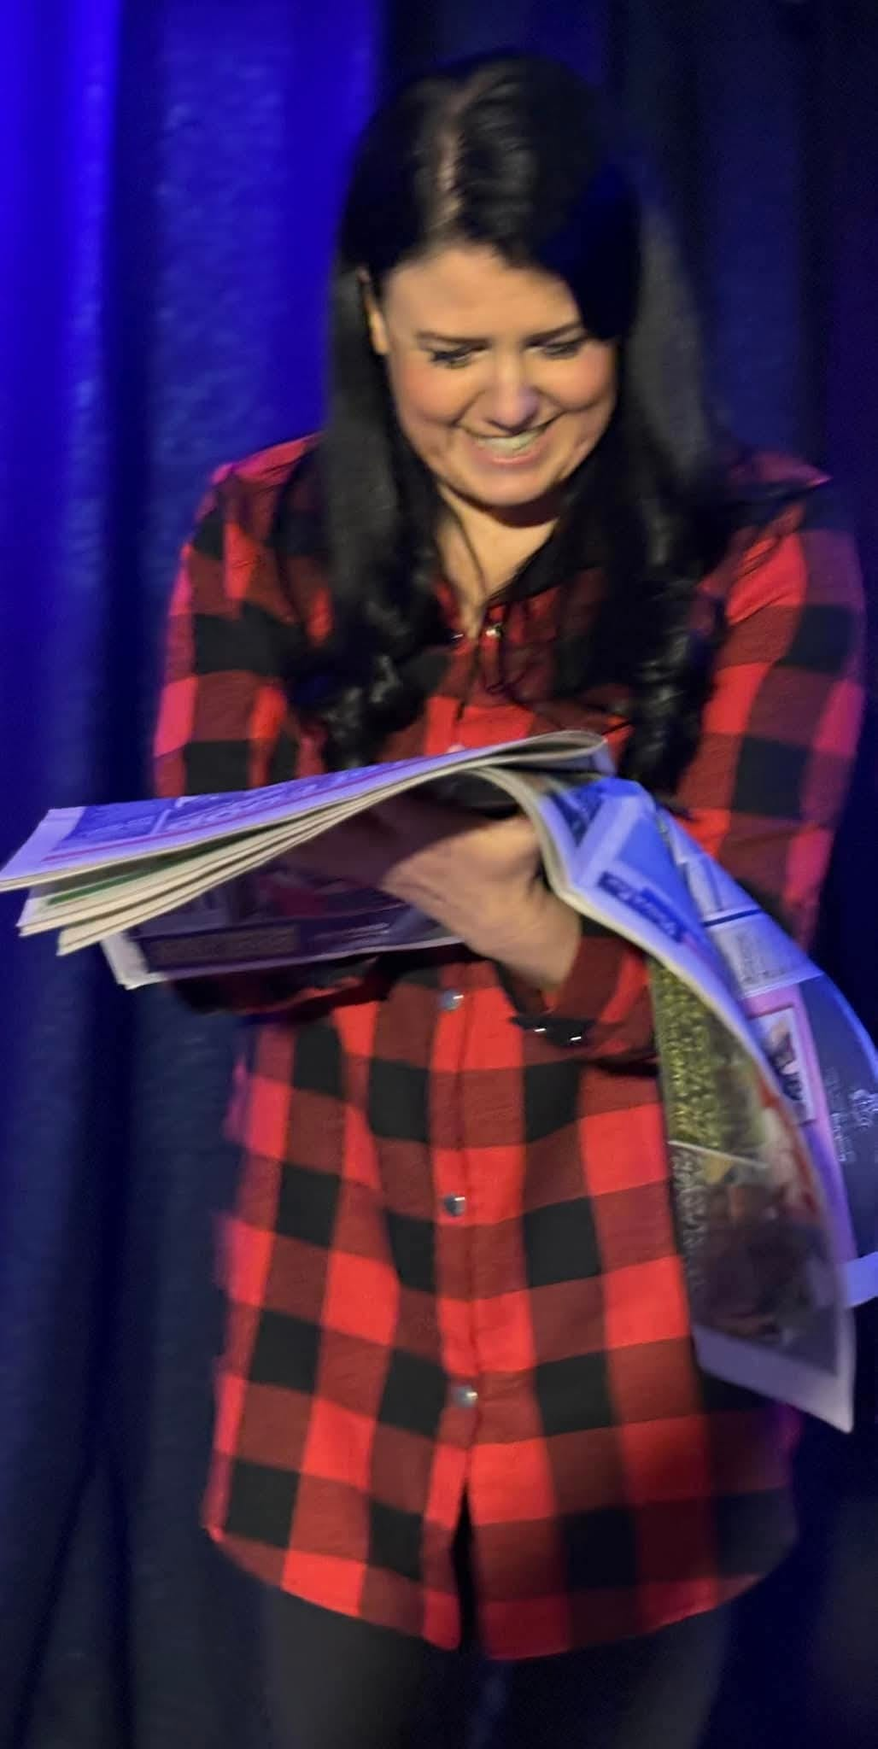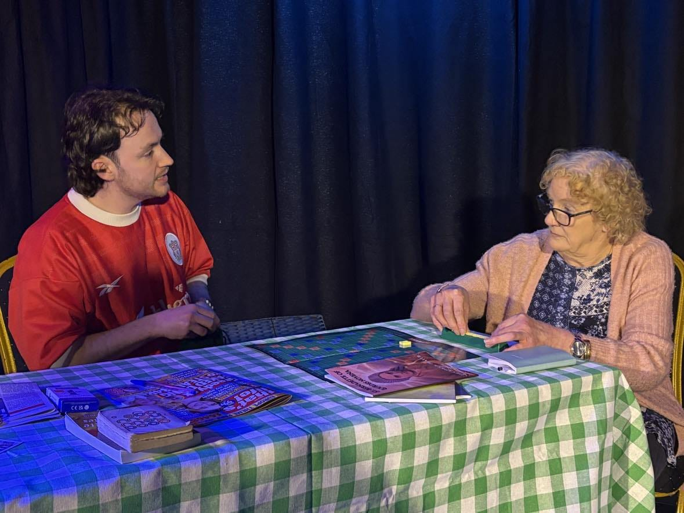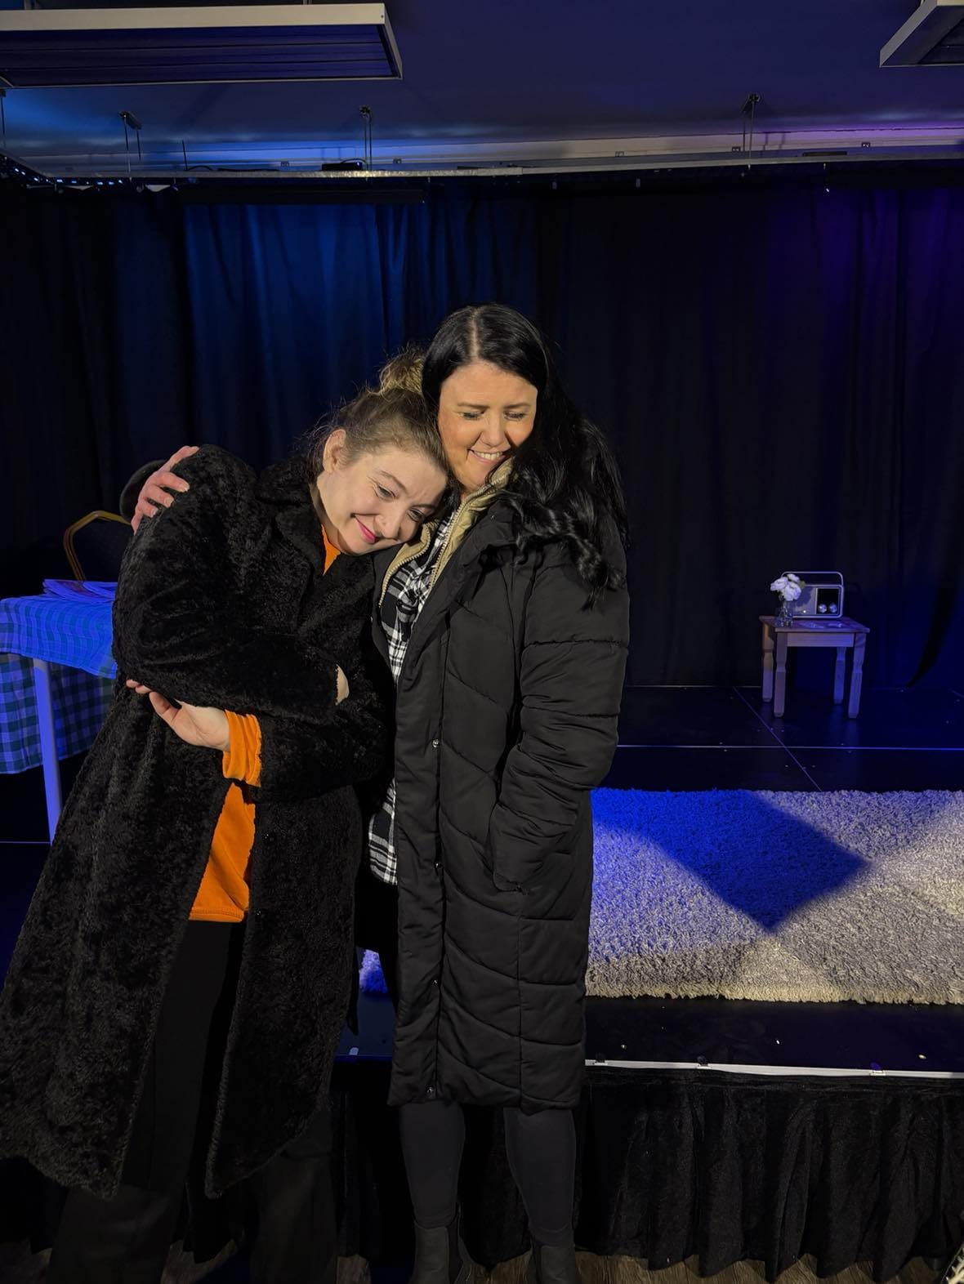

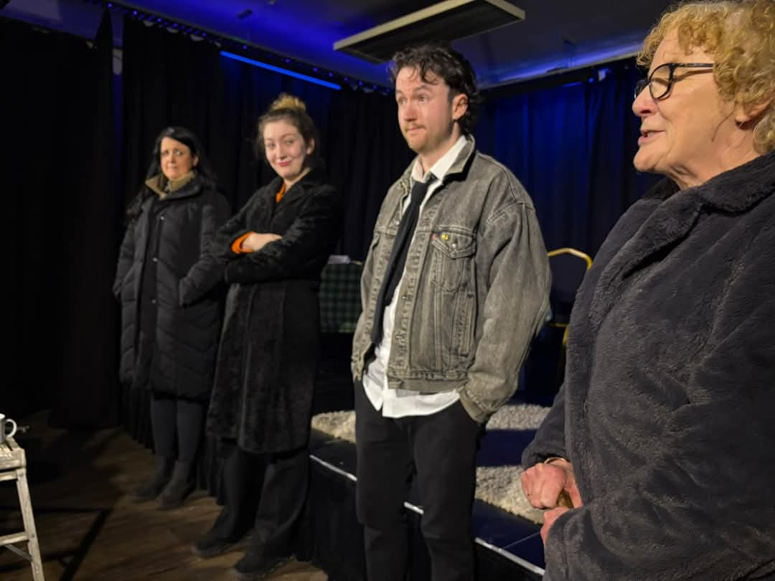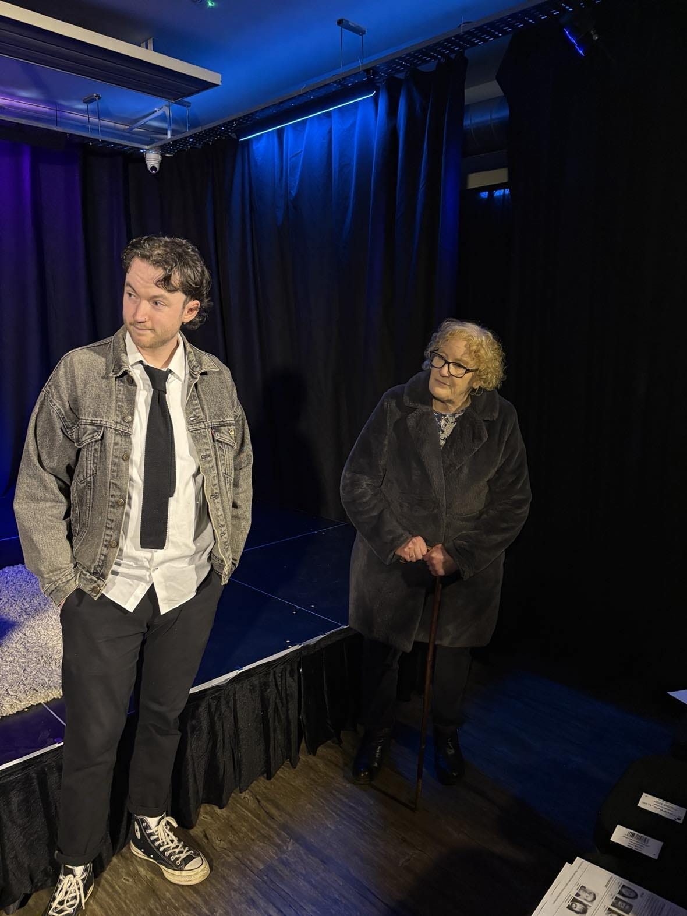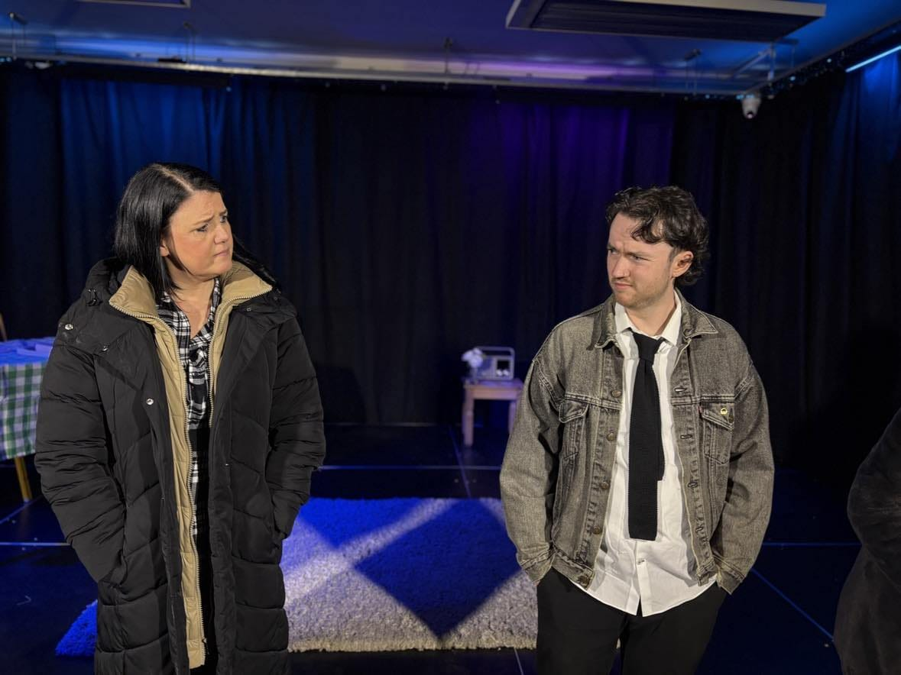

St Bernadette is an important figure for Grace and Gran and upon finding out that her relics are coming to their hometown of Liverpool, it is a date and they are going to visit her. Kate Harcus’ infectious excitement had me ready to join them! As St Bernadette is the patron saint of illness amongst other things, Grace particularly wanted to take Gran, and the fear she plays in worrying about her mum and her health is probably what a lot of us all feel about our parents once we (and they) get to a certain age. Of course Berni will be coming to visit the relics, and by virtue of now living at the house, Steven will also have to go. But he is a part of the Anglican church community, something which provides laughs over the course of the play, particularly from Gran with her biting remarks!

Some of my favourite moments were when our cast were sitting at the table playing cards and various things whilst chatting away. Bernie’s direction here worked a treat. Having the actors keep their performances natural and grounded made me really listen to what they were saying, therefore making it less ‘performing in a play’, and more ‘real life that happens to be on a stage.

Liz Hardy has some brilliant comedic timing, with one of the bigger laughs brought on by her delivering a single ‘naughty’ word in response to Steven’s vegan food plans for them that night!

James Lawrence is so good at playing the abashed and awkward, usually at the hands of Gran but his good-hearted nature does lead to these lovely moments between them, where he quietly wins her over and she slowly thaws to him. This is shown when Gran is unable to go to mass and Steven finds her an alternative that had us listening to hymn playing in the background. Some of the sound clips across both plays add the appropriate ambience to the scenes.

Whilst there were many light moments during the play, a special mention to the scene where Grace and Gran give a funny running commentary on Steven’s guitar playing sound clip, but when it suddenly goes quiet, their imaginations run wild about what Steven and Berni are up to in the bedroom, as mentioned earlier, the characters all had their own issues going on. Bernie was subtle in how much we learned about Grace’s problems, and the scene between Kate and Liz was emotional and raw, you could feel the pain both women felt - the regret from Gran at not having done enough, and Grace feeling that she didn’t get the help she needed from her mum at a crucial time in her life. A lot was implied in the scene, and perhaps Bernie wanted us to draw our own conclusions about Grace’s past trauma and secrets so that some people would be able to relate to her but with their own trauma.  
  
Nina Price is a revelation especially when giving those emotional performances. Every part of her is expressing the emotion, from shaking hands, to the shaky voice, the pacing, the moments of quiet, she gave everything, and you could feel it - I just wanted to get up there and give her a hug! The cast truly supported each other and collaborated well on that stage from start to finish, and it was wonderful to see. There will always be adlibs made by actors but the dialogue in this play was fantastic. Sharp, quick-witted, funny and heartbreaking, the few weeks we get as an insight into their lives helped build a picture in my head of exactly who they would be in the real world, and that is down to good writing and direction.In the last scene of the play, Bernie alluded to something terrible having happened to one of our new friends. I had my heart in my mouth the whole time until the misdirect was revealed! Loose ends were tied up, relationships were left strong and humour was still at the heart of it, as they all headed off to see St Bernadette’s relics.

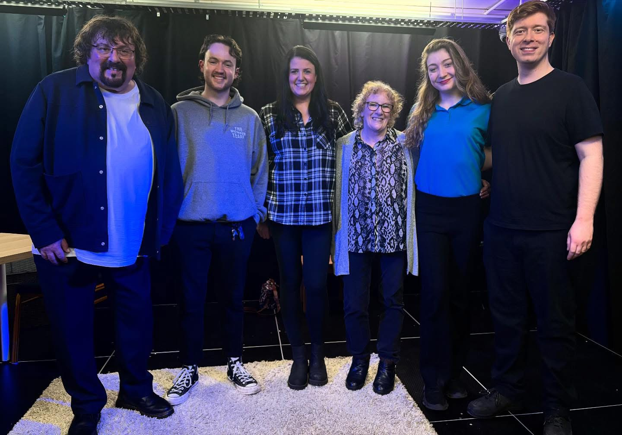

I was left well and truly satisfied. Bernie Winston, hats off to you as you created something special on that Friday night for us all. It is a massive shame that the opening night of these plays was also the only night they will be performed. Hopefully there is a reprise planned as more eyes need to see Bernie’s work and these actors’ talents on stage.

Reviewer: Bwalya Mutale-Kibaris - AMT Productions

Date: 7/03/2025

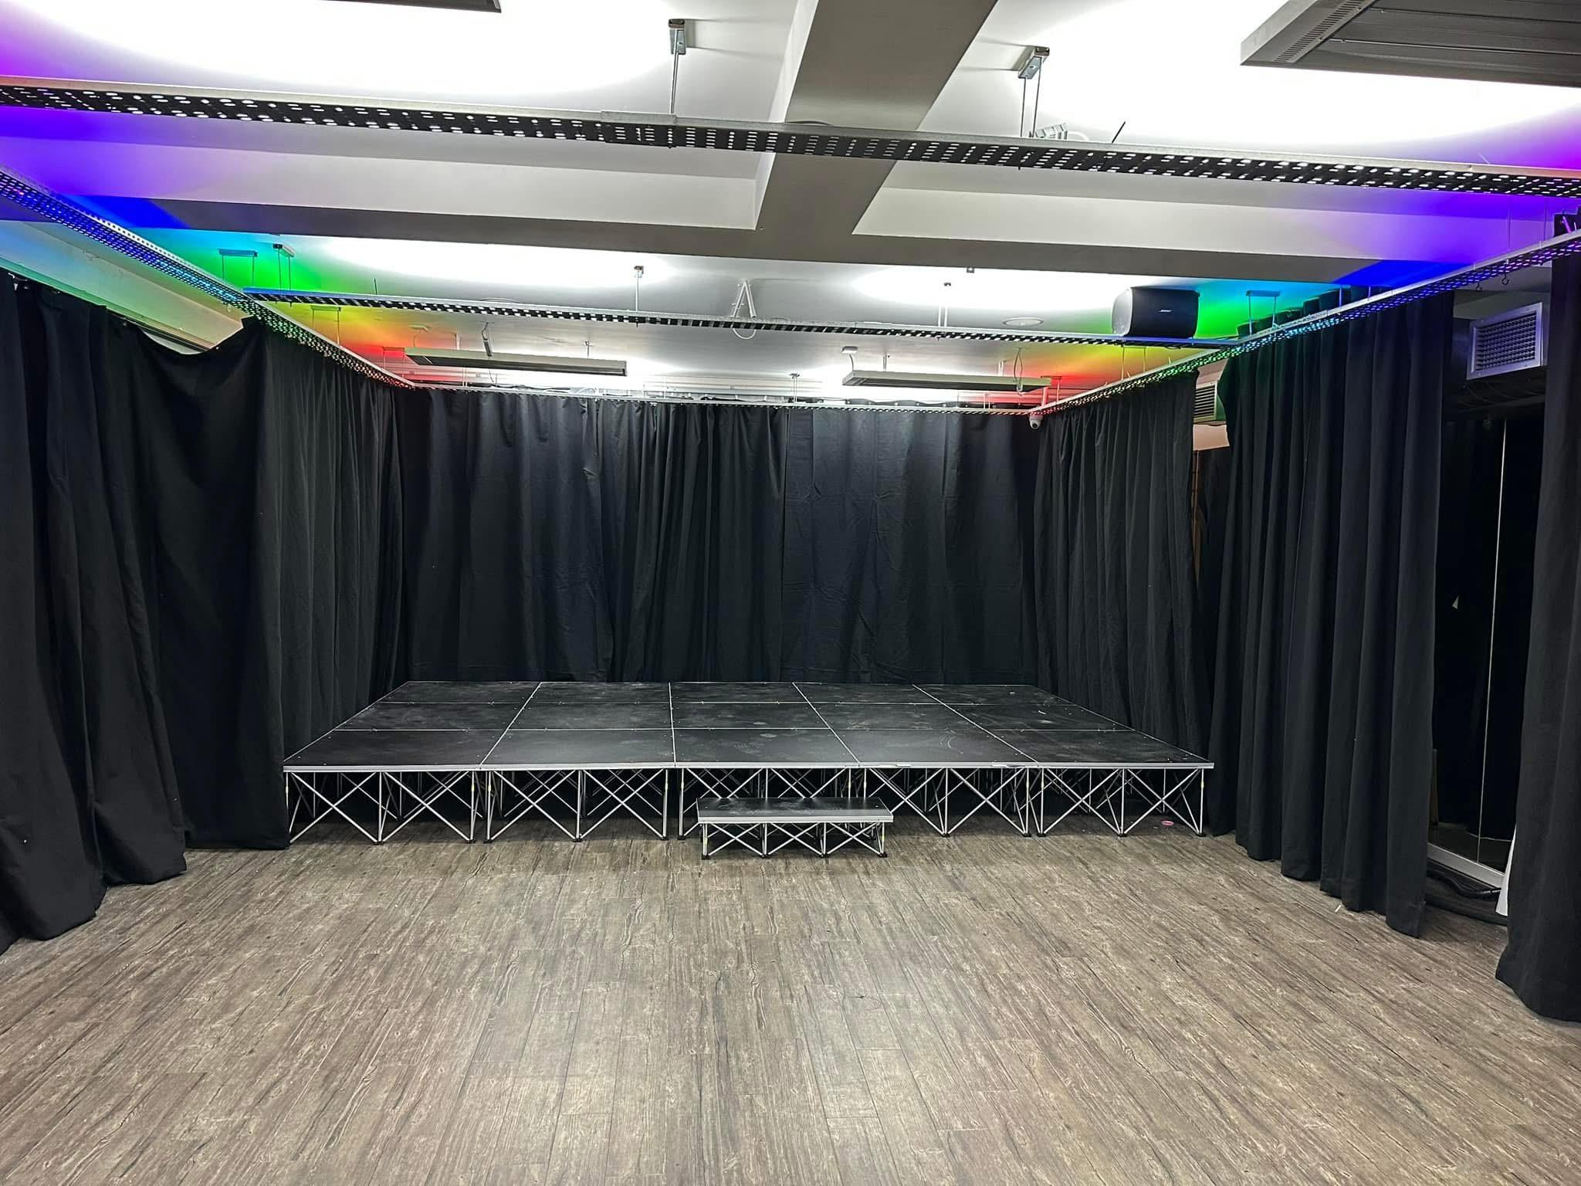

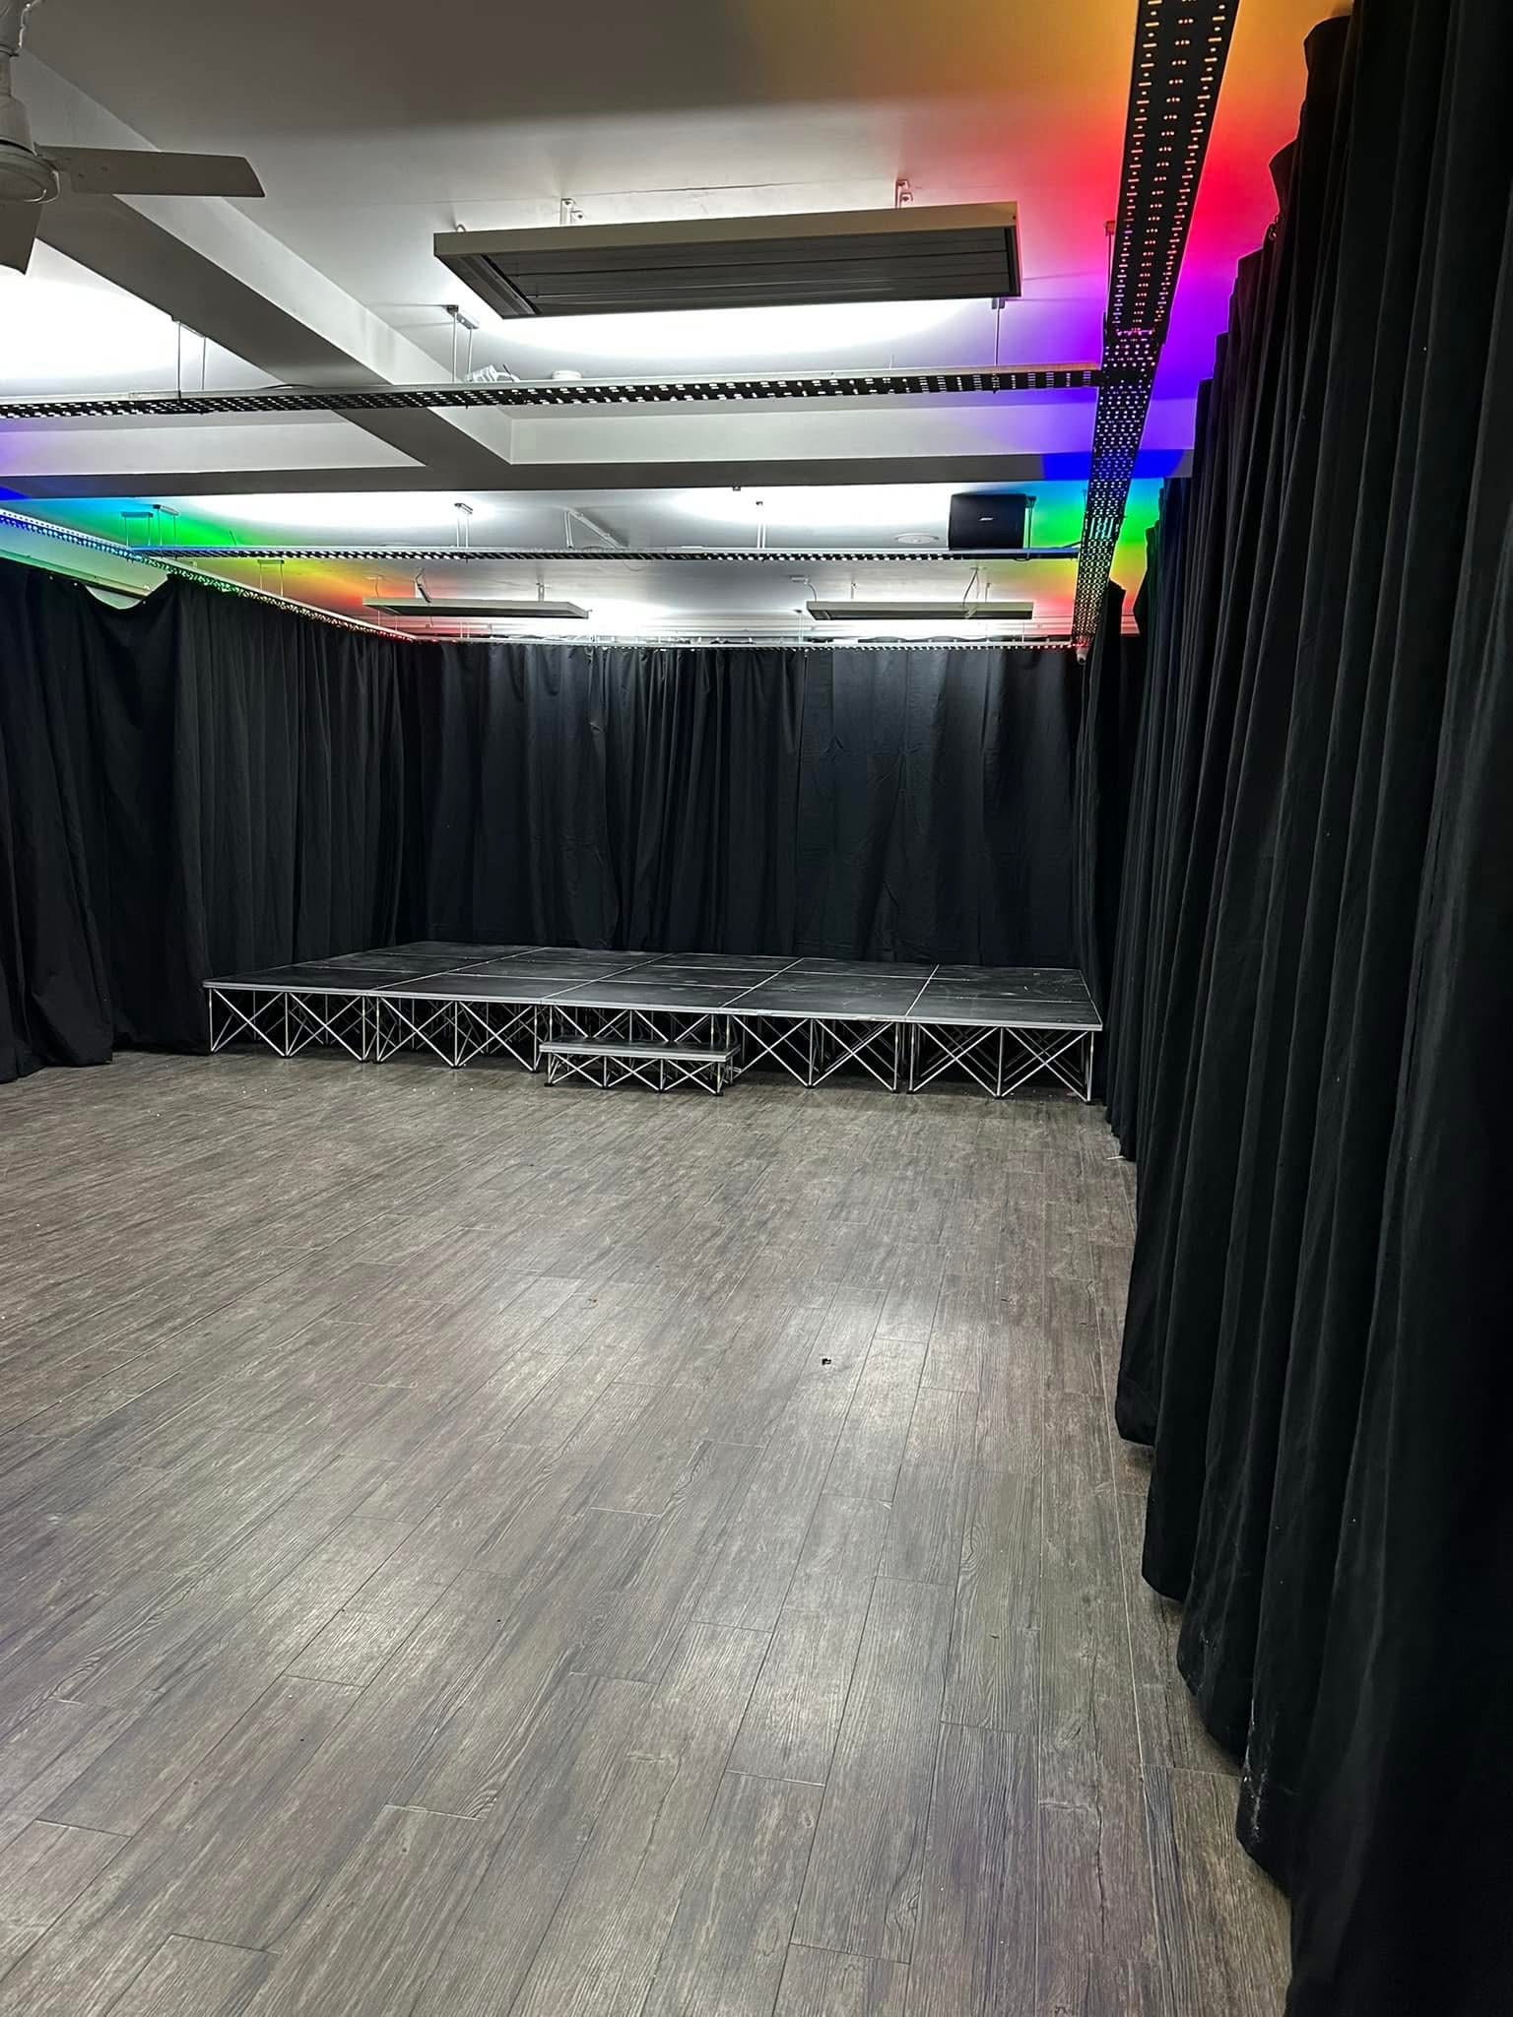

-The Venue -

Bringing original stories to the stage is something that the ‘**Make it Write Community**’ strives for. The team had the task of making their new venue, ***Studio Beyond***, ready in a matter of weeks after moving from their previous space, ***Studio Below***. It is impressive what people can achieve when they come together and put in the hard work. Bernie Winston has worked with ‘**Make it Write Community**’ for a few years now, and to keep coming back is testament of how supportive they are to those they are working with.

The building will have a rooftop terrace, which will be a great addition for those summer months (and winter if there are heaters!) where many future intervals can be spent. Upstairs, there will be podcast studios that will be ready for hire, which in this very podcast popular world is a great investment. There is a space directly above the theatre that is the same size which could become a second theatre room, and both these spaces can also be turned into dance studios or rehearsal spaces which gives plenty of options for either commercial or community use.

Collaboration, diversity,versatility and championing people's ambitions are big goals for ***Studio Beyond***. Contact the team for any further information or queries for use of the venue or their ‘**Make it Write Community**’ on [**ted@studiobelow.co.uk**](mailto:ted@studiobelow.co.uk)



**If you want to see more or Bernie Winston's work why not catch ‘Bad Blood’ at the Leverhulme Drama Festival. Please follow the link below to book your tickets. https://gladstonetheatre.org.uk/events/leverhulme-drama-festival/**